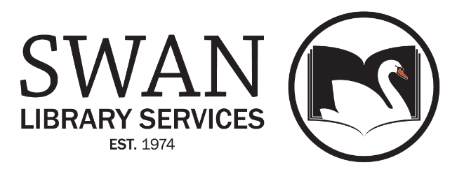

AGREEMENT FOR SWAN CATALOGING LIBRARIES
There are no additional SWAN fees associated with being a SWAN Cataloging Library. Libraries wishing to become SWAN Cataloging Libraries must fulfill the following requirements.

Library administrators/directors please write your initials on the following

_____ Commit to maintain the position of a cataloging supervisor with one of the following qualifications:

The cataloging supervisor must have a Master’s Degree in Library Science, and must have taken at least one class in cataloging. The supervisor must have 3 years of cataloging experience, with the ability to perform original cataloging in all formats.

OR

The cataloging supervisor must have taken at least one class in cataloging from an accredited MLIS program, have 3-5 years of cataloging experience, with the ability to perform original cataloging in all formats.

OR

The cataloging supervisor must have taken at least one class in cataloging offered by an accredited LTA program, RAILS, the Cataloging Maintenance Center, or other source or have equivalent cataloging experience with the ability to perform original cataloging in all formats, and have discussed these qualifications with and received approval from the SWAN Bibliographic Services Manager.

_____ Cataloging supervisor will be responsible for cataloging output of subordinate staff and act as a point of contact for communication from SWAN staff regarding feedback, quality control, and distribution of resources

_____ In the event that the cataloging supervisor changes, this application will be resubmitted for SWAN review.

_____ Cataloging libraries will be responsible for providing full OCLC/MARC records for materials acquired by their libraries if full OCLC/MARC records are not already in SWAN. Records must be reviewed by library staff and brought to SWAN standards outlined in SWAN support site documentation.

_____ The SWAN Bibliographic Services Manager will provide procedural training to the cataloging supervisor of a SWAN Cataloging Library. However, the Manager will not provide cataloging training, as such.

_____ The cataloging supervisor will attend required meetings to discuss quality control and SWAN standards and review updated documentation and communications as they are released. Meetings will be infrequent and have options for virtual or asynchronous participation.

_____ The cataloging supervisor will observe the following standards and conventions:
- The way in which a bibliographic entity is described will be based on current international cataloging formats and standards outlined by SWAN staff and Cataloging Advisory. Currently, this includes these standards and vocabularies:
  - ISBD: International Standard Bibliographic Description
  - RDA: Resource Description and Access
  - Library of Congress Authorities, Subject Headings, and Genre/Form Terms
- The means with which a bibliographic entity is entered will be based on:
- Bibliographic Formats and Standards, latest ed. / OCLC
- Cataloging Standards outlined on the SWAN Support Site.
- Shared catalog records will be furnished with a valid OCLC number.

_____ The SWAN Bibliographic Services Manager will monitor the work of the SWAN Cataloging Library. The SWAN Board, upon the recommendation from the SWAN Bibliographic Services Manager, may terminate the library’s cataloging role if the library does not conform to these standards.

If all the above requirements are met and future obligations are agreed to, the SWAN member library seeking status as a SWAN Cataloging Library will contact the SWAN Bibliographic Services Manager directly. Based on this agreement and an interview with the applying cataloging supervisor, the SWAN Bibliographic Services Manager will make a recommendation to the SWAN Board for approval.

Library Name

Library Administrator/Director Name

Library Administrator/Director Signature

Date

Cataloging Supervisor Name

Cataloging Supervisor Signature

Date

Please send the signed copy (or scanned copy) to:

Scott Brandwein  Bibliographic Services Manager  scott@swanlibraries.net  844-792-6542 | SWAN  800 Quail Ridge Drive  Westmont, IL  60559

SWAN Internal Use Below

SWAN Bibliographic Services Manager Recommendation on Library Application

____ Yes _____No

Comments from Bibliographic Services Manager:

SWAN Board Approval Date ____________________

SWAN Membership Start Date ____________________

