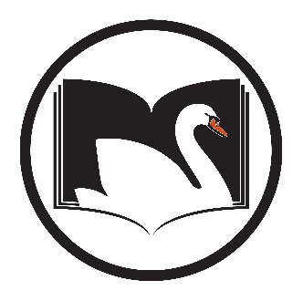

SWAN Cataloging Users
  - Thursday, June 4, 2020, 9:30 AM – 12:00 PM
  - GoToMeeting
Register on L2 : https://www.librarylearning.info/events/?eventID=30254
GoToMeeting Access:
Please join my meeting from your computer, tablet or smartphone.
https://global.gotomeeting.com/join/188253381
You can also dial in using your phone.
(For supported devices, tap a one-touch number below to join instantly.)
United States: +1 (646) 749-3112
Access Code: 188-253-381

Chairs:
- Claudia Nickson, co-chair, SWAN
- Sandra Leyva, co-chair, Alsip-Merrionette Park Public Library
- Welcome and introductions, notetakers
- Re-opening plans, Tech Services operations, and current priorities
- Combo Pack cleanup – review of pre-cats when separating combos
- Inconsistencies with volume field
  - Weeklies/Chronology
  - Travel Guides, Graphic Novels, and Monographic Serials
- Review of Rec_Status fixed field / Fiction-Nonfiction field
- Quality Control – auditing and feedback on pre-cat inconsistencies
- Open discussion
- Next Meeting
October 1st, 2020, 9:30 AM – 12:00 PM (TBD) - Register on L2 : https://www.librarylearning.info/events/?eventID=30255

