Large print missing the 590 and the 3xx fields:
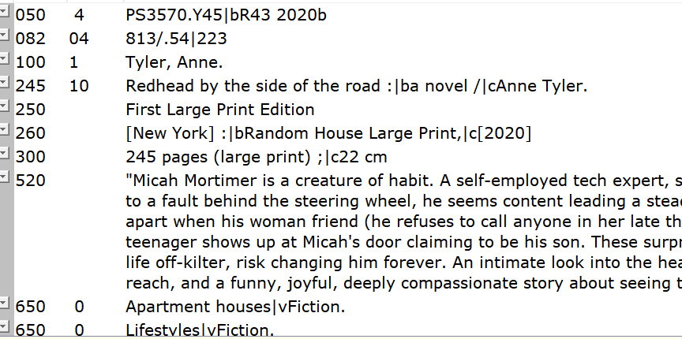

Unauthorized heading:
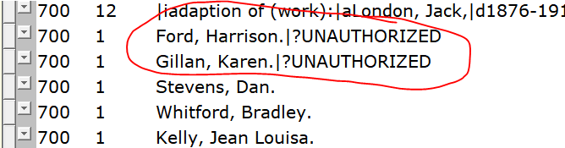

Discrepancy between bib record and fiction/non-fiction facet:
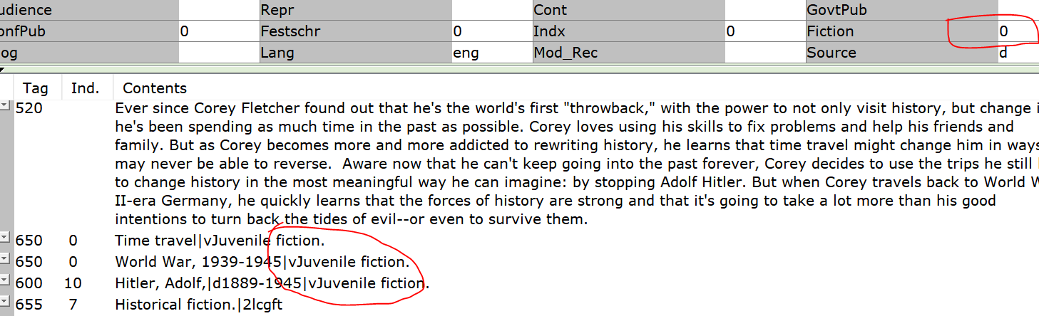
Missing 650 _0:
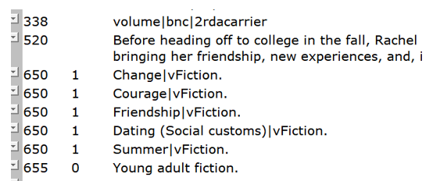

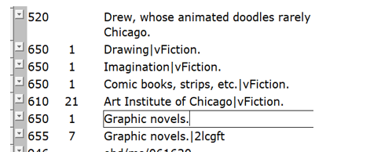

Missing 520 – series statement was also added to the record.
