Uncle Scrooge
9781631403880 (v. 1 per Amazon)  9781684050543 (v. 9 per Amazon)  9781684055104 (v. 13 per Amazon)  9781684053957 (v. 11 per Amazon)  9781631408229 (v. 6 per Amazon) | Amazon has each listed as a volume within a “series”. Yet, no series/volume information was found on the book. Also, records in WF are all cataloged differently.  See below for examples of records (in order by ISBNs listed)

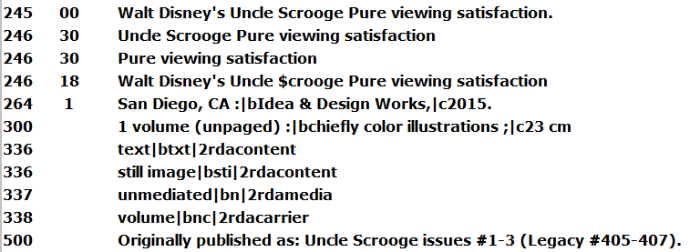
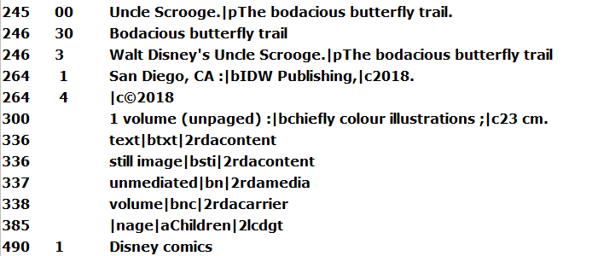
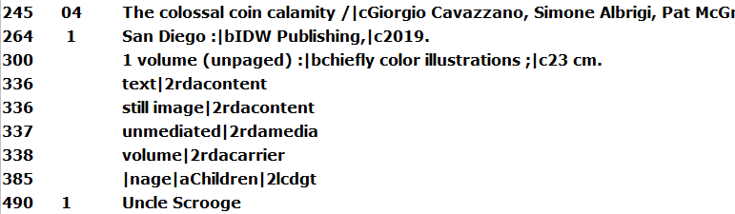
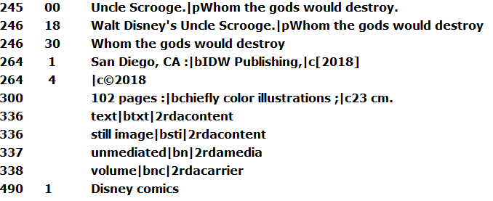
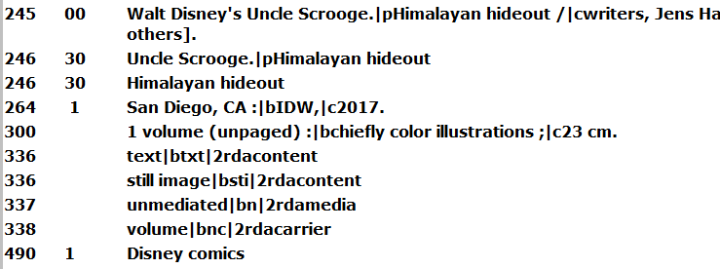
Once Upon a
9780553534351 | WF has a series statement/number, but book does not mention the series or number. However, Amazon does have the series/number. Was the WF series information added because of Amazon? If so, should a note be added to the Workflows record indicating where the series information came from?  Should we go by Amazon for “series” information and add a note indicating where this information came from in the record? In which case, the Uncle Scrooge” records (first example above) would need to be modified with the volume information from Amazon.

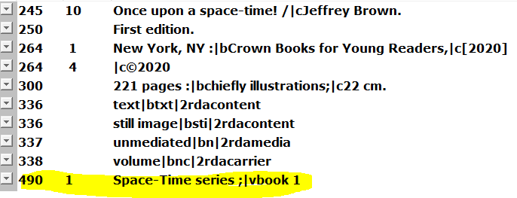

Amazon screenshot:
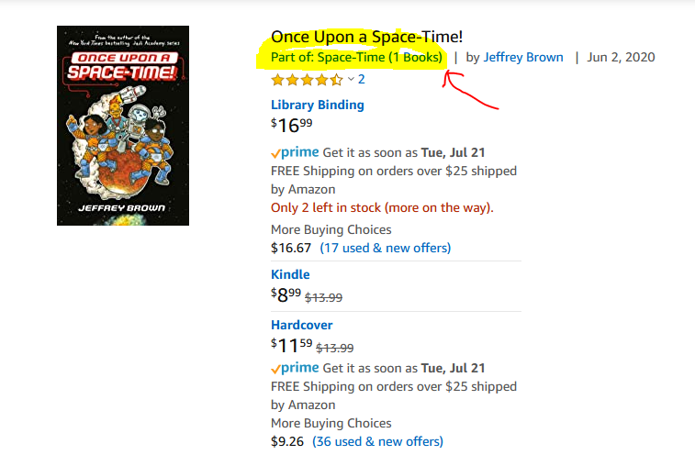

Ronin Island
9781684155576 | When is something considered a series that goes into a 4XX/8XX field vs. a title series in the 245 tag and subfield |p with no 4XX/8XX field?  See first example of Uncle Scrooge above. Should “Uncle Scrooge” be a series (4XX) or a title series (245 tag) using the |p subfield?

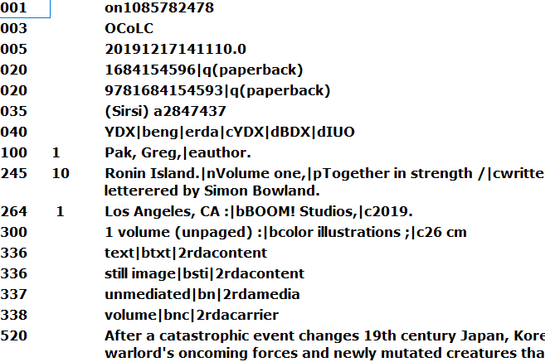

Ms. Marvel
9781302918293 (v. 1)  9781302918309 (v. 2) | When is something considered a series that goes into a 4XX/8XX field vs. a title series in the 245 tag using subfield a .|n and ,|p with no 4XX/8XX field?  See first example of Uncle Scrooge above. Should “Uncle Scrooge” be a series (4XX) or a title series (245 tag)?  Note: The 1st volume is cataloged with “Ms Marvel” in a 4XX tag. The 2nd volume does not have a 4XX tag. Amazon has the series as “The Magnificent Ms. Marvel” (see screenshot below), which is present on the back cover of each book. Should this series be added to both the records along with the volume information?  Also, the 2nd volume in the series has and 246 tag with “Ms. Marvel by Saladin Ahmed.|nVol. 2,|pStormranger”. Whereas, the 1st volume does not have this additional/alternate title.
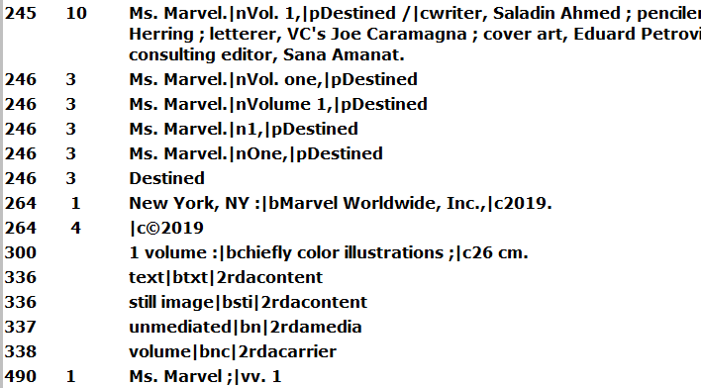
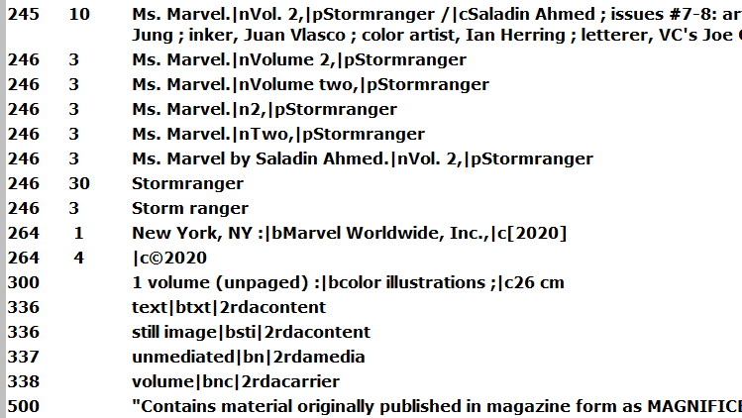

Amazon screenshot:
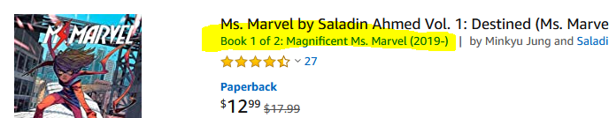

Nathan Hale’s Hazardous Tales
9781419708084 (v. 4 per Amazon)  9781419731488 (v. 8 per Amazon) | WF has a 4XX field for both records, but only 9781419731488 has the volume information. No volume information could be found in either book. I believe the volume information was take from Amazon?

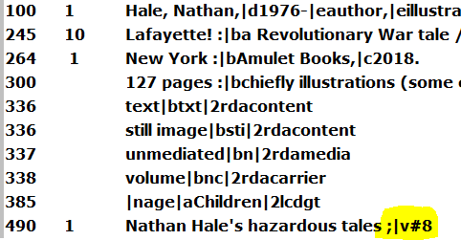

DC Super Hero Girls
9781401289706 (book 6 of 17 per Amazon) | Amazon was this listed as a series “DC Super Hero Girls” with volume information.  In WF, the only record with a 4XX tag is the highlighted title below. Also, this is the only title within the “series” that is using a :|b instead of .|p in the 245 tag.

The first 2 records (with a red check) are pre-cats (short)
