Journey Mapping:

eBooks & eAudiobooks in Enterprise

Persona & Scenario: Carol  Carol loves to use her library. She usually prefers print, but she is interested in trying eBooks because she got a ___________(device) for her birthday. She is comfortable using the library catalog and prefers to search for both print and ebooks to see what is available. But she has signed up for a__________(vendor) account because she saw a bookmark at her library. | Goals & Expectations  - With an account already set up…  - Find and download or stream an item from the library catalog
Search  Emotional Experience |  | Request or Download |  | Read or Listen

Opportunities

Instructions

Before you start
You will need a device – you can use your computer, phone, tablet, or a Kindle.
You will also be assigned a St. Charles Public Library test card and one of these vendor formats:
- Hoopla
- Overdrive
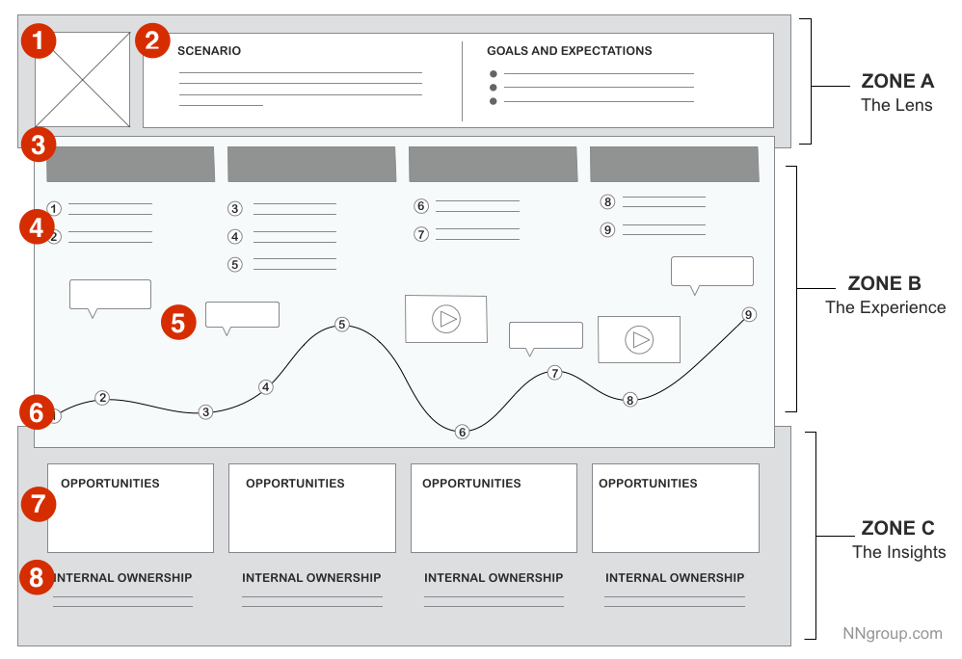
- Baker & Taylor Axis 360
- Cloud Library
As the persona, go through the process of downloading or putting a hold on an eBook or eAudiobook. You can choose any title, unless you are assigned Hoopla – we want to avoid incurring costs for St. Charles, so you need to use a free title.
If you are checking out a Hoopla item, you must use one of the titles from this list: https://www.hoopladigital.com/tag/6219881919

Document your journey
- Note the actions under each journey phase (4)
  - Actions are the actual behaviors and steps taken by users. This component is not meant to be a granular step-by-step log of every discrete interaction. Rather, it is a narrative of the steps the actor takes during that phase.
- Note the thoughts or questions the user has. (5)
  - Mindsets correspond to users’ thoughts, questions, motivations, and information needs at different stages in the journey. Ideally, these are customer verbatims from research.
- Plot emotions across the journey phases (6)
  - Emotions are plotted as single line across the journey phases, literally signaling the emotional “ups” and “downs” of the experience. Think of this line as a contextual layer of emotion that tells us where the user is delighted versus frustrated (use your emojis )

Group discussion
All groups will reconvene to identify opportunities:
- What needs to be done with this knowledge?
- Who owns what change?
- Where are the biggest opportunities?
Figure 1 Source: https://www.nngroup.com/articles/customer-journey-mapping/
- How are we going to measure improvements we implement?
And finally: How does this journey compare to our previous activity with Enterprise?

