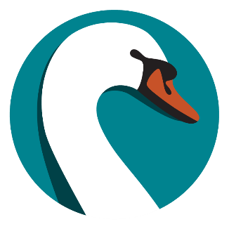

SWAN RFID Users Group

Agenda

Thursday, October 24th, 2024, 10AM-11:30AM

Online via Zoom and In-Person at Linda Sokol Francis Brookfield Library, 3541 Park Ave, Brookfield, IL 60513.

Link and connection information available via the [SWAN Support Site](https://support.swanlibraries.net/meeting/94429)

Chairs:

* Ahren Sievers, SWAN
* Rebecca Bartlett, La Grange Public Library

1. Welcome and Introductions
2. ILA Conference and SirsiDynix Connections Update
3. WorkFlows 4.1 Update
4. SWAN RFID Libraries and AMH
5. 2023-2024 Projects
6. SWAN Support Site - RFID
7. SWAN Forums
8. Open Discussion/Library Tour